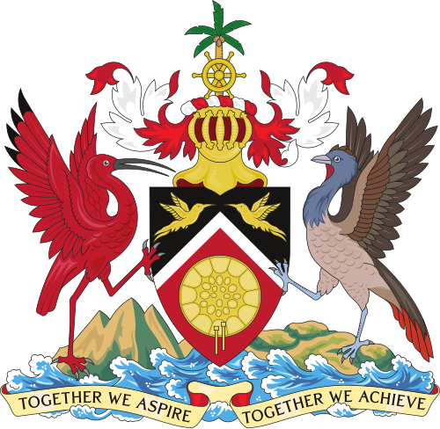

COAT OF ARMS FOR TRINIDAD AND TOBAGO

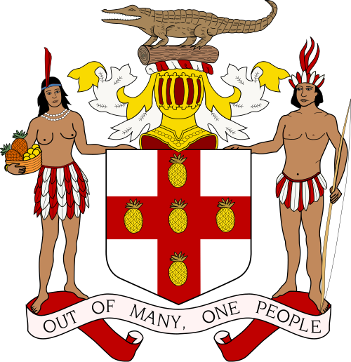

COAT OF ARMS FOR JAMAICA

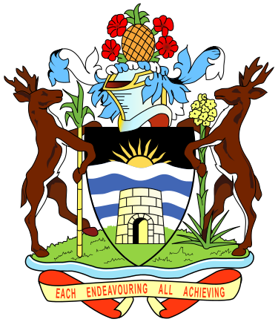

COAT OF ARMS OF ANTIGUA AND BARBUDA

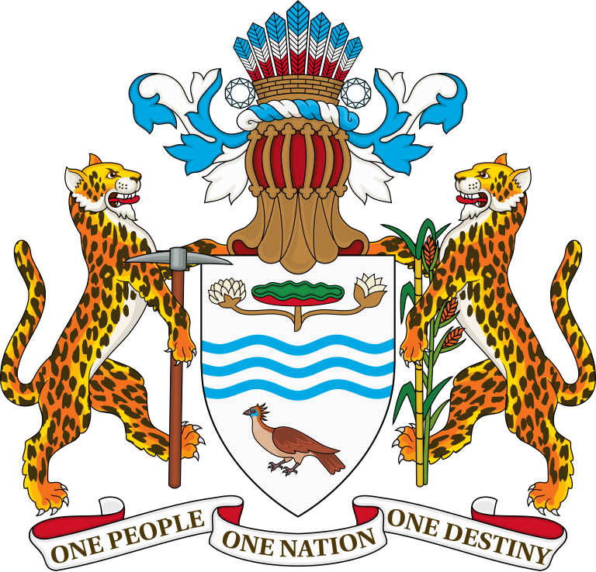

COAT OF ARMS OF GUYANA

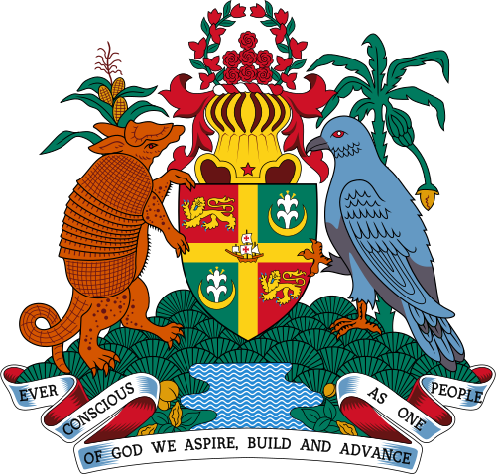

COAT OF ARMS OF GRENADA

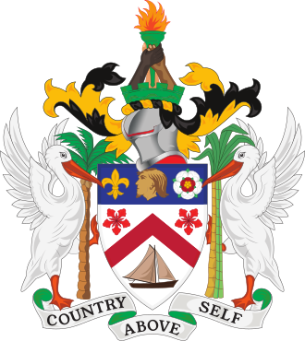

COAT OF ARMS OF SAINT KITTS AND NEVIS

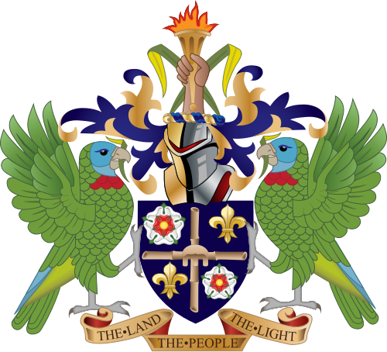

COAT OF ARMS OF SAINT LUCIA

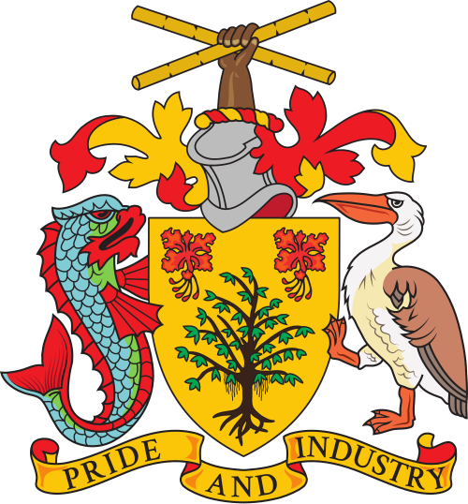

COAT OF ARMS OF BARBADOS

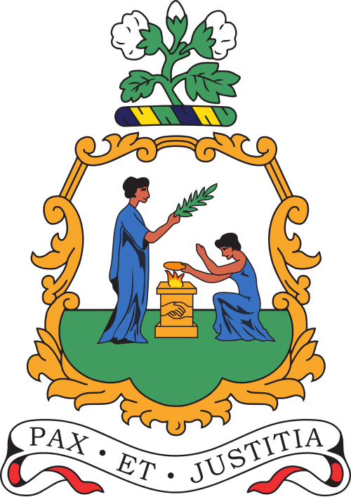

COAT OF ARMS OF SAINT VINCENT AND THE GRENADINES

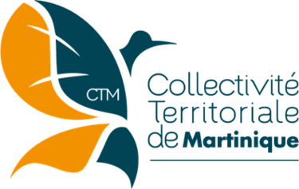

The Territorial Collectivity of Martinique has adopted a logo to represent itself. The logo was adopted on 1 August 2016, following a design competition opene to all people of age living in Martinique. Out of 647 eligible proposals, a design by 22-year-old graphic artist Stévy Desbonnes was selected. The logo features a [hummingbird](https://en.wikipedia.org/wiki/Hummingbird) whose wings form a stylized map of Martinique. The [ochre](https://en.wikipedia.org/wiki/Ochre) colour represents the local soil and the blue represents the ocean

COAT OF ARMS FOR TRINIDAD AND TOBAGO

DESIGN

The palm tree crest at the top of the coat of arms was taken from Tobago's coat of arms before it was joined in political union with Trinidad. The shield comprises the same colours (black, red, and white) as the nation's flag and carry the same meaning. The two birds on the shield are hummingbirds. Trinidad is sometimes referred to as the "Land of the Hummingbird" because 18 different species of hummingbird have been recorded on the island. "Land of the Hummingbird" is also believed to have been the Amerindian name for Trinidad. A gold steelpan, the national instrument, is featured below them. The two larger birds are the Scarlet Ibis (left) and the Cocrico (right), the national birds of Trinidad and Tobago. Below the Scarlet Ibis are three hills, representing the Trinity Hills in southern Trinidad, which, it is believed, convinced Columbus to name the island after the Holy Trinity. The island rising out of the waters beneath the Cocrico represents Tobago. Below these birds is the nation's motto, "Together We Aspire, Together We Achieve." The original was designed by Carlyle Chang and George Bailey.[5]

REVISION

In August 2024, Prime Minister Keith Rowley announced at the annual convention of the People's National Movement that his government planned to remove Christopher Columbus's sailing ships from the coat of arms (present since their initial adoption in 1962) and replace them with the steelpan drum, the national musical instrument,[6] as part of efforts to remove "colonial vestiges".[7] A bill to do so was passed in the House of Representatives and Senate in January 2025, and received assent from the President of Trinidad and Tobago on 29 January. Gillian Bishop was tasked with the new design, which was unveiled on 19 January 2025.[8] On 21 February 2025 the proclamation was issued giving effect to the new design, which came into use from 25 February 2025.[9][10]

THE COAT OF ARMS OF JAMAICA

The coat of arms of Jamaica is a heraldic symbol used to represent Jamaica. The coat of arms is a legacy design, with its earliest iteration having been granted for the colony of Jamaica in 1661 under Royal Warrant. The original design was created by William Sancroft, then Archbishop of Canterbury. The present design was adopted after Jamaican independence in 1962, with slight modification.

SYMBOLISM

The motto of the seal has been a matter of discussion for years since inception. The original motto, INDUS UTERQUE SERVIET UNI is the Latin translation for "The Indians twain shall serve one Lord". The motto was replaced in 1962 with the English motto "Out of Many, One People",[2] as tribute to the unity of the different cultural minorities inhabiting the nation. The United States has a similar motto, e pluribus unum, meaning "Out of Many, One" in Latin.

COAT OF ARMS OF ANTIGUA AND BARBUDA

The coat of arms of Antigua and Barbuda was designed in 1966 by Gordon Christopher. It was officially introduced on 16 February 1967. The symbolism of the arms is more complex than that found on the flag of Antigua and Barbuda, but many elements are similar.

At the top of the coat of arms is a pineapple, a fruit for which the islands are famous. There are several plants found around the shield, all abundant in the country: red hibiscus, sugarcane, and century plant (Agave americana). Supporting the shield is a pair of deer representing the wildlife of the islands.

The design on the shield shows the sun, also found on the flag, rising from a blue and white sea. The sun symbolises a new beginning, and the black background represents the African origins of many of the nation's citizens. At the bottom of the shield, in front of the sea, sits a stylised sugar mill. The sun on the shield represents the six parishes of Antigua, and, the island of Barbuda.[1]

At the bottom is a scroll upon which is written the national motto: "Each endeavouring, all achieving".[2]

COAT OF ARMS OF GUYANA

The Amerindian Headdress symbolizes the Amerindians who are the indigenous people of Guyana, i.e., the first people to live in the country.

The Helmet is a monarchical insignia that indicates that Guyana was once a Monarchial country ruled by a King or Queen.

The Two Diamonds at the side of the Amerindian Headdress symbolize the country’s mineral wealth.

The Jaguar holding the pickaxe symbolizes labour.

The Jaguar holding the stalk of Rice and Sugarcane symbolizes our two main agricultural crops, sugar and rice.

The Shield signifies protection for the nation.

The Three Blue Wavy Lines on the shield represents the many rivers of Guyana (Essequibo, Demerara, Berbice).

The Victoria Regia Lily on the shield is the National Flower, which was discovered by Robert Schomburgh, a German Botanist discovered in 1837.

The Canje Pheasant or Hoatzin at the bottom of the shield is the National Bird. It is rare bird which is found mainly in this part of the world.

The banner to the bottom of the coat of arms with the words One People, One Nation, One Destiny is the National Motto.

THE COAT OF ARMS OF GRENADA

The coat of arms of Grenada is the official heraldic achievement of the Caribbean island state of Grenada. It was granted by royal warrant of Queen Elizabeth II on 6 December 1973.[2]

Description

The primary feature of the arms is a shield divided into four parts by a golden cross. In the centre of this cross is the Santa Maria, Columbus' flagship during his first voyage to the Americas.[3] A lion passant guardant on a red field is shown in the upper left and lower right sections of the shield, representing the island's British heritage, as well as strength and determination. A golden crescent moon out of which a lily grows occupies the upper right and lower left sections, symbolising the island's dedication to the Virgin Mary.[4][5]

The shield is surmounted by a royal helmet, symbolising the monarchy,[6] topped with a garland of bougainvillea branches, the national flower. Within the garland are seven red roses, which stand for the seven communities of Grenada (the six parishes and the Southern Grenadines). The shield is supported on the dexter side by a nine-banded armadillo which stands before a corn stalk; on the sinister side is a Grenada dove, which stands before a banana plant. The base represents Mount St. Catherine with the Grand Etang Lake at the centre. A ribbon displays the national motto: "Ever conscious of God we aspire, build and advance as one people."

THE COAT OF ARMS OF SAINT KITTS AND NEVIS

The coat of arms of Saint Kitts and Nevis was adopted in 1983 and possesses the motto "Country Above Self". The previous coat of arms, adopted in 1967 by the colony of Saint Christopher-Nevis-Anguilla, was nearly identical, except for coloration and the motto "Unity in Trinity".

The centre of the coat of arms is dominated by a shield at the base in which there is a lighter in full sail (one of the traditional means of transportation). A red chevron is highlighted by two poinciana flowers.

At the top of the shield is a Carib's head, flanked by a fleur-de-lis and a rose. The Caribs were the early inhabitants of the islands, and the fleur-de-lis and rose signify the islands' French and British influences.[1] A helmet topped with the battlements of a tower appears with a flaming torch upheld by three hands: one African, one European and one Indian. The torch signifies the struggle and quest for freedom by a people of diverse ethnic origins, but united in purpose.

The shield is supported on either side by pelicans (the country's national bird), with wings extended, displaying a sugar cane plant and the coconut palm tree, which are extensively cultivated throughout Saint Kitts and Nevis.

THE COAT OF ARMS OF SAINT LUCIA

The coat of arms of Saint Lucia was adopted on 8 January 1979 by a royal warrant of Queen Elizabeth II.[1]

The national motto (the land, the people, the light) is found at the bottom of the arms.

OFFICIAL DESCRIPTION

The government of Saint Lucia describes the arms as follows:[1]

Azure two sticks of cut bamboo in Cross surmounted of an African stool of authority Or between in dexter chief and sinister base a Rose Argent charged with another Gules both barbed and seeded proper an in sinister chief and dexter base a Fleur-de-lis Gold and for the Crest upon a Helm with a Wreath Or and Azure in front of two Fronds of the Fern Polypoduim [sic] in Saltire a Cubit Arm proper the hand holding erect a Torch Gold enflamed also proper and for the Supporters on either side a Saint Lucia Parrot commonly called Jacquot (Amazona versicolor) wings elevated and addorsed and in the beak of each a Frond of the Fern Polypoduim [sic] all proper and for the Motto: THE LAND-THE PEOPLE-THE LIGHT.

THE COAT OF ARMS OF BARBADOS

The coat of arms of Barbados was started on independence in 1966. Like other former British lands in the Caribbean, the coat of arms has a helmet with a national symbol on top. It has a shield beneath that is supported by two animals.

The national symbol on top of the helmet is the fist of a Barbadian. It is holding two stalks of sugar cane that are crossed to resemble St. Andrew's Cross. This is for the importance of the sugar. Barbados has its national independence day on St. Andrew's Day.

The shield is gold in colour. On it are two of the national flower, and a single bearded fig tree. The shield is supported by a dolphin fish and pelican. They are for the fishing industry and Pelican Island.

At the bottom is Barbados' national motto "Pride and Industry" on a scroll.

THE COAT OF ARMS OR NATIONAL SEAL OF SAINT VINCENT AND THE GRENADINES

The coat of arms or national seal of Saint Vincent and the Grenadines is surmounted by a cotton plant and bears the text "Peace and Justice" in Latin. The centerpiece is based on the colonial badge in use from 1907 to 1979 and features two women in classical Roman dress. The one on the heraldic right stands holding an olive branch and the one on the left holds scales of justice and kneels before a gold altar situated between them.[1] The coat of arms was designed by Elaine Liverpool.

THE COAT OF ARMS OF MARTINIQUE

The coat of arms of Martinique is based on the island of Martinique's controversial snake flag which features a white cross on a blue field with a white fer-de-lance viper (Bothrops lanceolatus) in each corner. The symbol was first used following a 4 August 1766 edict specifying that vessels of the French colony of Martinique and Saint Lucia should fly a version of the French ensign—which at the time was a white cross on a blue field—with L-shaped (for Lucia) snakes in each quarter of the cross. The controversy comes as those vessels were active participants in the Trans-Atlantic Slave Trade with locals highly discouraging the use of the flag, and by extension the coat of arms.

In October 2018, the National Gendarmerie directorate in Martinique stopped using the emblem by order of President Emmanuel Macron.[1]

LOGO

The Territorial Collectivity of Martinique has adopted a logo to represent itself. The logo was adopted on 1 August 2016, following a design competition opene to all people of age living in Martinique. Out of 647 eligible proposals, a design by 22-year-old graphic artist Stévy Desbonnes was selected. The logo features a hummingbird whose wings form a stylized map of Martinique. The ochre colour represents the local soil and the blue represents the ocean